Design for an Internet Naval Operations Database
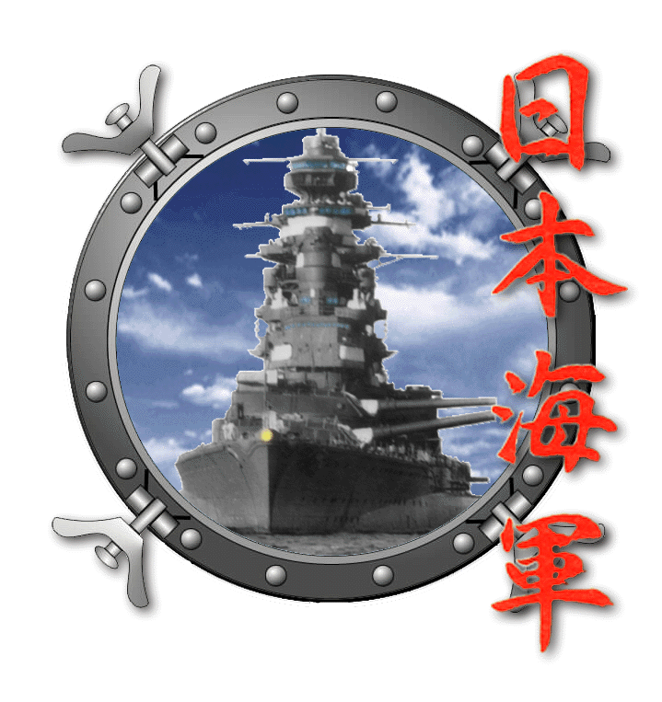

Project Overview

Project Description: The development of an object-oriented naval operations database will make studying the Pacific War much easier, as it will allow a more perceptive treatment of how historical events, ships, and men interact over time. This application represents an important advance in the art of military history. The database will reside on the Imperial Japanese Navy Homepage, at: http://www.skypoint.com/members/jbp/kaigun.htm.
Project Needs: The author is seeking a programmer/developer with knowledge of Java, Object or SQL databases, and Web technologies such as DHTML and/or Javascript. The developer will work with the author to create the database. The developer would be responsible only for development work; all data entry tasks and other “drudge work” associated with populating the production database will be performed by the author and his associates.
About the Author: Jon Parshall is the owner of the Imperial Japanese Navy Homepage. This Web site has been in continuous operation since 1995, and receives some 80,000 visits annually. It is a collaborative effort, with four primary researchers, and several other contributors. I am a business analyst by profession, and work for a large Twin Cities-based Web development firm. I can be reached at home at 612.825.9615, or at jonp@key-tech.net. When sending an email, please reference “Operations Database” in the subject line—I get a lot of email.

Introduction
In the field of naval history, there has yet to be a satisfying solution offered to the question of “How can one model and study the operations of a navy engaged in a war?” The standard answers to this problem, be they hardcopy or databases, have revolved around creating either:
- A general history of a battle or campaign, in which the general flow of the engagement is detailed,
- A reference work devoted to an individual ship or class of ships, which will sometimes contain a history of ships’ movements (often referred to as a Track Record of Movement, or TROM), or
- An Order of Battle (OB) for a particular point in time, which outlines the structure of the navy, and its sub-units and individual ships.
These are useful efforts, but they do not provide adequate tools for dealing with the quantitative aspects of the war. My interests as an amateur historian cover all aspects of the Pacific War, but focus particularly on the economic, logistical, and operational aspects of the conflict. In these topic areas, there’s no substitute for having bodies of relevant numbers at your fingertips. For instance, some of the more interesting questions a naval historian with my bent might ask include:
- “How many destroyers did the Japanese Navy lose from January through June, 1943?”
- “What was the aggregate tonnage of escort warships launched by the Imperial Navy during 1944?”
- “What were the names of every destroyer skipper in the Imperial Navy in May, 1942?”
- “At a glance, show me the weaponry upgrades that this ship went through.”
- “What was the increase in the average number of 25mm AAA mounts on a typical Japanese Type-A cruiser from 1942 to 1944?”
- “What was the difference in operational tempo for Japanese destroyers in 1942 compared to 1944?
In addition, an attempt must also be made to model the spatial characteristics of the navy. Where were the ships operating? Where did they get sunk? Where were they most often stationed? These questions must be addressed in an operational study, and a well-designed database should be able to supply spatial answers via a map of some sort. Better yet, with a map-driven Web interface (which this design specifically does not cover, but which lays the foundations for), a well-designed database might provide answers for questions of the following types:
- “Show me the locations of every Japanese destroyer in the summer of 1943.”
- “Show me the location of every damaged ship in the Japanese Navy on this date.”
- “Show me the ports with the highest incidence of surface traffic during this time period.”
At present, answering any of the questions above would require the most painful sort of brute-force methods and manual tabulation. With a properly designed database, addressing these issues would be trivial.
The truth is that while books and orders of battle are fairly good at conveying narrative, images, or organizational structure, they do a poor job of conveying how things change over time, i.e., they present a snapshot, rather than a movie. In real life, ships get built, get sunk, get transferred from squadron to squadron, and even change the composition of their armament and other equipment as time progresses. Commanding officers come and go. The organizational structure of a navy, particularly during war, is constantly in flux. Portraying the time element of naval operations is crucial to developing an understanding of the subject, and any serious effort at modeling the problem domain needs to tackle these temporal issues.
To date, no one has successfully implemented what I refer to as a true “Naval Operations Database”, which tracks the interaction of personnel, ships, and their organizations (squadrons, fleets, etc.) as they proceed through the string of historical events (battles, convoys, refits, etc.) which comprise a war.
The following document details a preliminary design for a true naval operations database. This includes:
- A structure of object-oriented (OO) Java code classes that describe the interaction of ships, men, and events.
- A description of the user interface required for the application.
- A series of use cases on how actions would be performed within the system by various actors.
- A design for adding ‘hooks’ to the initial system so that it may one day be matched with an online mapping system.
- Technical and architectural requirements for the system.

Important: this design is preliminary. While I believe that I have a reasonably comprehensive knowledge of the historical domain, and also possess some skills in capturing requirements for OO and Web systems in general, I am completely open to suggestions on improving any aspect of the system. The interface, in particular, is wide open for improvements. While the interface designs presented in this document may seem relatively complete, they are not. They present only a preliminary feel for which data elements need to go on a given screen. My personal feeling is that the interface in general does not flow particularly well. Feedback on this, or any other aspect of the system is helpful. The bottom line is that my Web site is a truly collaborative effort between myself and my main contributors; I view this project in the same light. I fully expect that this design will evolve and improve with the input of the developer(s).

Database Model

Describing Time in a Naval Operations Database
The basic model in this application is to create a dual hierarchy of historical events:
- Multi-ship events—any event containing more than two vessels, including such things as battles, individual convoys, landing operations, and so on.
- Ship’s Log Events—Events that concern an individual vessel, such as being launched, refitted, engaging in combat, being sunk, etc.
Ships can associate their log events with those of a multi-ship event. By doing so, they also create a relationship with all the other ships associated with the multi-ship event.
Furthermore, to help depict a sense of organization at the level of the battle, we will create an association between the multi-ship event object and any number of force sub-groupings within the event itself—we’ll call these “Task Forces”. These task forces reflect the ad-hoc force groupings that were specific to a given battle plan, but which were not based on the (semi)-permanent organizational affinities (i.e. formally belonging to a squadron) which pertained throughout the course of the war. This approach allows us to model the various groups within a given battle. Ship events will not only be tied to the battle object, but also to one of the Task Forces within that battle. This model is illustrated below:
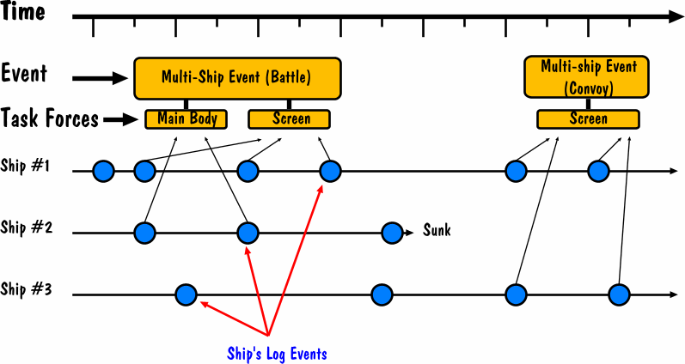
For example, the Battle of Midway would be a (fairly important) multi-ship event. This event would contain several Task Forces within it corresponding to “First Fleet, Main Body”, “First Mobile Force, Carrier Striking Force,” etc. Several ships would have individual ship events associated with the battle itself, and to the Task Force they operated with. By creating such an association, it is easy to search the database at the multi-ship event level to find out A) what ships were present, and B) what they did. This approach facilitates very rapid tabulation of OBs for any given battle, and also creates cross-referenceable TROMs for all the ships in the battle. Much of the work of populating the database will be comprised of creating these events and associating them with each other.
It should be noted that this approach does not make it possible to construct a complete OB for the entire Navy. We will be recording the association of ships with their operational divisions; nothing more. In real life, divisions are attached to squadrons (or kantai in Japanese), and squadrons to operating groups (butai) or fleets (sentai). This database will capture only the lowest of these organizational building blocks, as well as the larger ad-hoc groupings that were present in some of the larger named battles (Midway, Coral Sea, Eastern Solomons, etc.) Thus, the database will be able to produce good OBs for any given battle, but it would not be able to describe the middle levels of the formal organizational structure of the Navy. It would be possible to extend the object model to accommodate these issues, but I fear the price would be a great deal of added complexity for not much in the way of additional benefit.

Modeling Ships Over Time
At its most basic level, a ship is nothing more than a hull structure in which various components are placed. Everything about a ship can change over time—number of guns, number of boilers, types of engines, horsepower, weaponry, fire control systems, radar, crew size, displacement, hull length and speed, even it’s name—but the notion of the ship remaining that same individual ship remains intact.
Ships tend to change very rapidly as a war proceeds. For example, during World War Two, additional anti-aircraft equipment (radar, fire control gear, and new AAA mounts) were constantly added to all surface combatants during their refits and repairs. Sometimes the added weight of this equipment was offset by the removal of equipment such as gun mounts, torpedo tubes and/or spare torpedoes. Consequently, the Operations Database must have the ability to quickly edit a ship’s composition, and link that change to a date/time identifier so that it can be tracked.
There are two ways to approach modeling this effect. The first is to formally create ship sub-component object correlating to the actual ordnance in question. For instance, a sub-component called “Triple 25mm AA Mount” might be created. Adding it to a ship would increase the ship’s total 25mm mounts by one, and its total 25mm barrels by three. This approach is more accurate in terms of reflecting the ship’s true makeup—for instance, one could run a report on the ship which would return that a given cruiser at date X had four triple 25mm mounts, two double 25mm mounts, and thirteen single 25mm mounts, for a total of (4x3)+(2x2)+(13x1) = 29 25mm barrels aboard ship. It also allows you to add/remove components in a logical fashion. However, it is more tedious to employ, because every component aboard the ship must be individually added to the hull.
The second method is to ignore the concept of a “mount” and simply note the total number of a given basic component aboard a ship at a given time. One then increments or decrements that attribute to note that the ship has changed. For instance, instead of noting the above information on 25mm anti-aircraft mounts, one would simply increase or decrease the total number of 25mm barrels to reflect the addition or subtraction of such weapons. This approach destroys some historical accuracy (since ship’s weapons are usually grouped), but is easier to administer.
At this point, I haven’t decided which approach to take, and am open to input from the developer.

Code Structure
As of this writing, the core of the system comprises some two dozen Java classes, which are illustrated below. I have stubbed Java class available for most of the core objects.
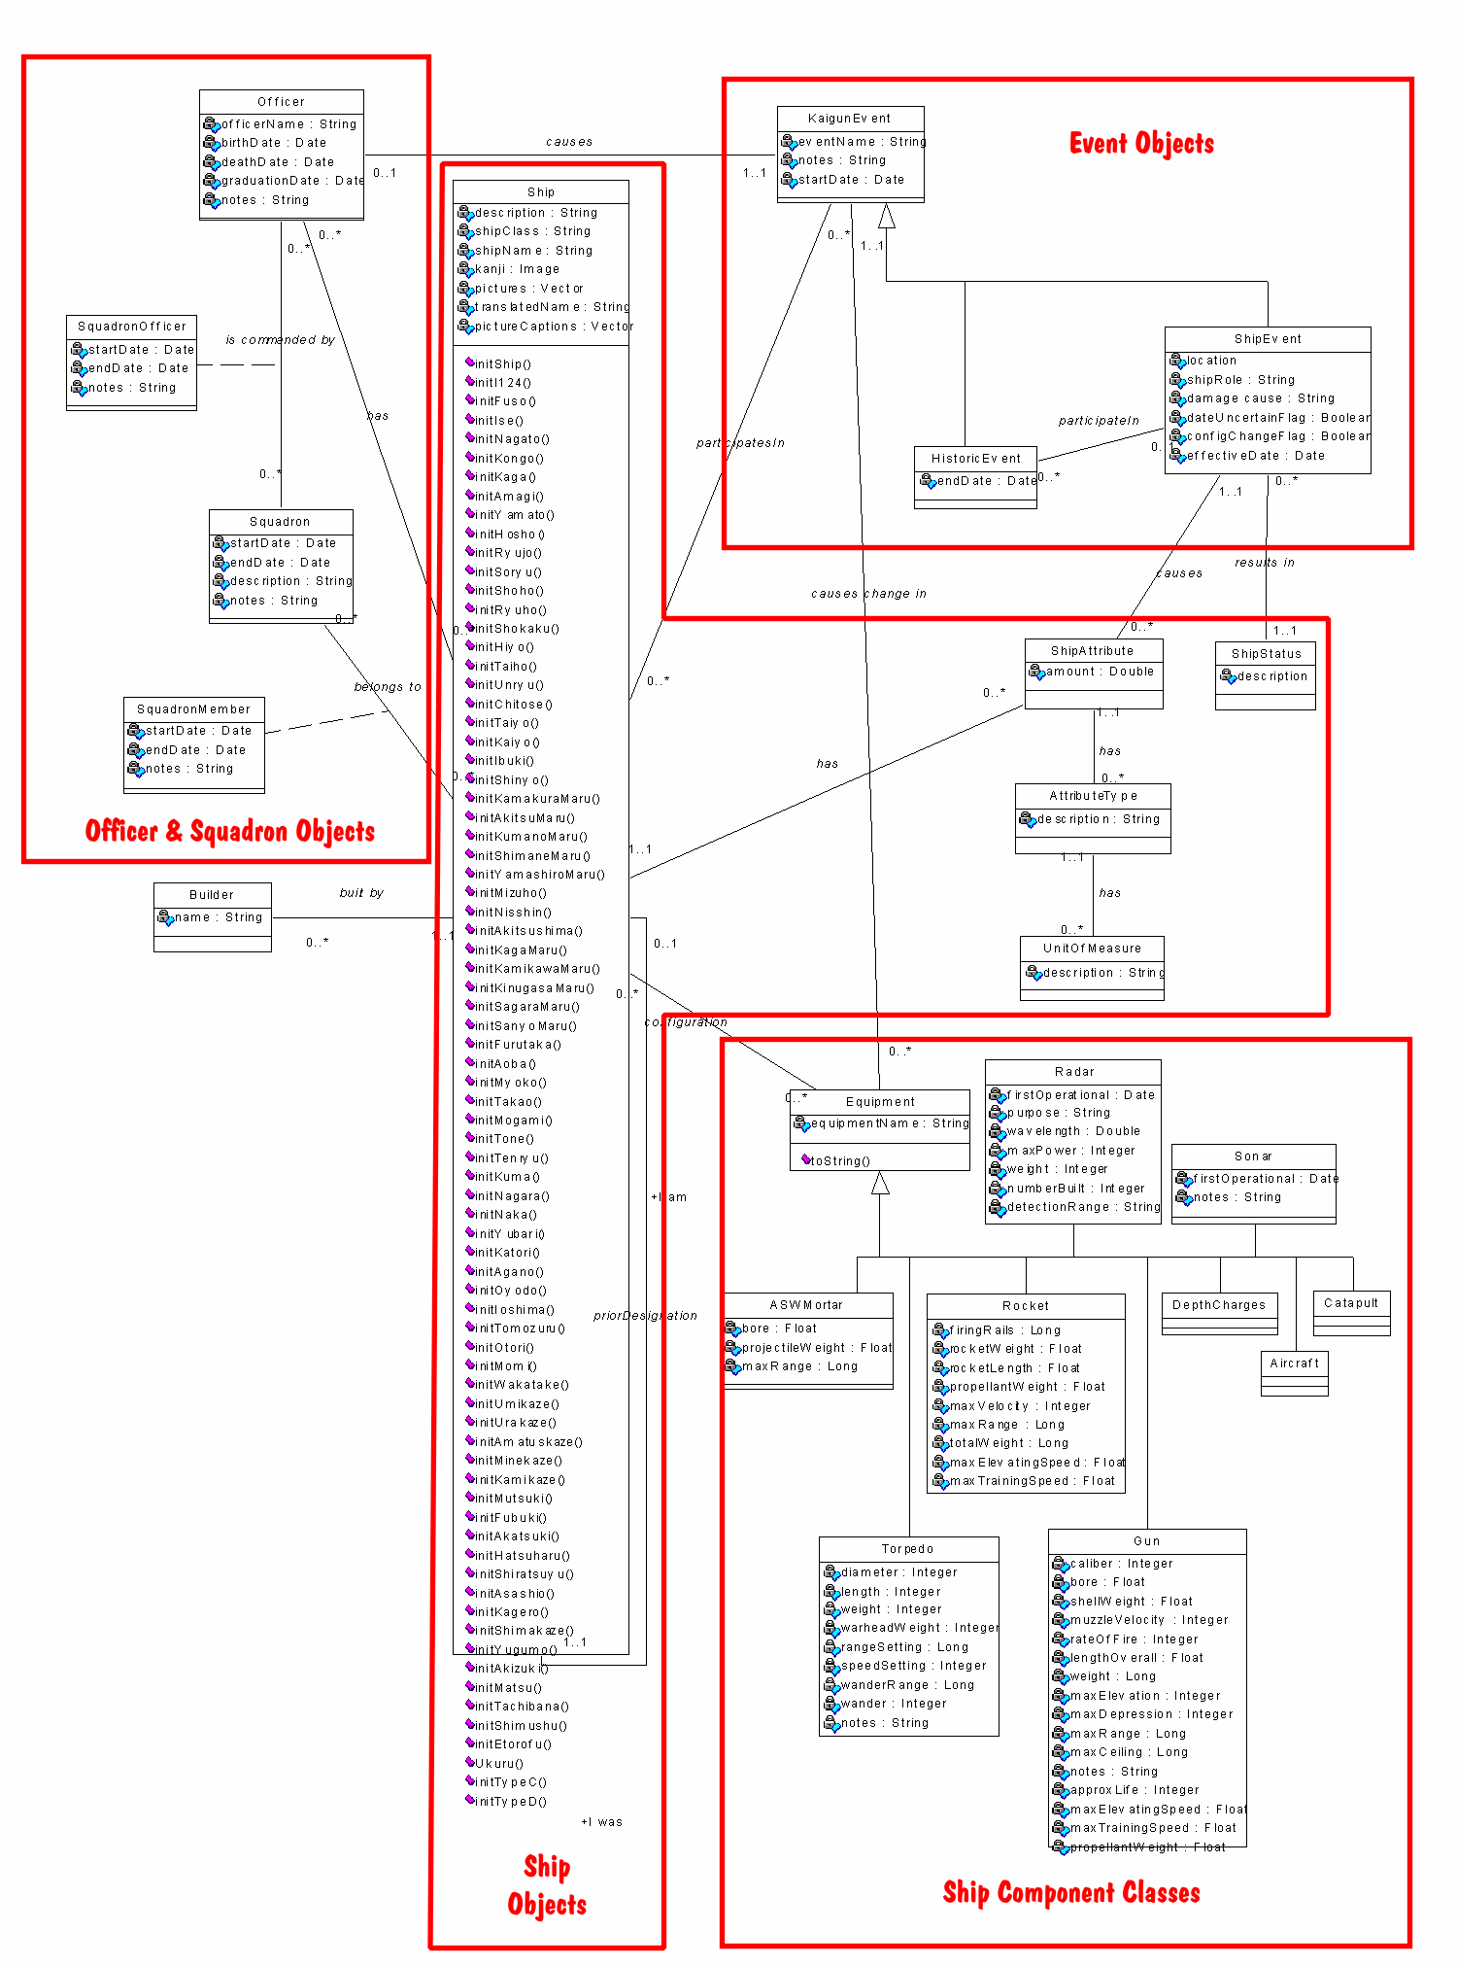

System Functions
The major features are grouped below by the system actors who will use them:
- End User—A visitor to the Imperial Japanese Navy Web site, who will be browsing for information regarding a ship, battle, or IJN officer.
- Historian—An individual who has access permissions necessary to load information, edit, and delete information from the database. In practice, this group of individuals will be rather small—myself, Allyn Nevitt, and Tony Tully to begin with.
- System Administrator—The person who will have direct access to the database, setting up system users, and so on. Jon Parshall will be the site administrator.
In general, the System Administrator will also have all the capabilities of both an Historian and an End-User. Likewise, Historians will also be able to access all the End-User capabilities while in the system. The following matrix illustrates this.

Functionality Matrix
Function/Actor | End-User | Historian | Admin
Browse For Ship | X | X | X
Browse For Event | X | X | X
Browse For Officer | X | X | X
Run Web Report | X | X | X
Add a Ship |  | X | X
Edit a Ship |  | X | X
Delete a Ship |  | X | X
Add a Multi-ship event |  | X | X
Edit a Multi-ship event |  | X | X
Delete a Multi-ship event |  | X | X
Add a Ship Event |  | X | X
Edit a Ship Event |  | X | X
Delete a Ship Event |  | X | X
Add an Officer |  | X | X
Edit an Officer |  | X | X
Delete an Officer |  | X | X
Create New Report |  | X | X
Create New System User |  |  | X
Edit New System User |  |  | X
Delete New System User |  |  | X
Maintain Database |  |  | X

Main Screen and General System Navigation
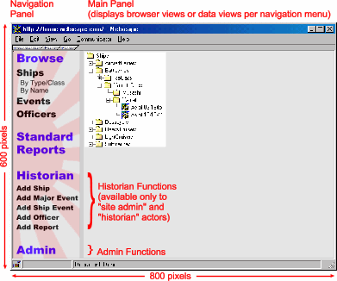
The main screen is divided into two main pieces of real-estate: the Navigation Panel, and the Main Panel. The navigation panel controls the content of the main panel. There are four main browse modes—ship browsing by ship type, ship browsing by alphabetical name order, event browsing by date, and officer browsing by name. Clicking on any of the browser modes in the Navigation Panel will cause the appropriate browser to appear in the Main Panel. Double clicking on an object in a browser will cause the browser to be replaced with an appropriate data screen—ship, event, or officer. Re-clicking on any browser button in the Navigation Panel will cause the browser to re-appear at the navigation point it was in—in other words, the application remembers the state of the four main browser views, and returns to those states when the browser view is selected again. This allows the user to retain continuity in their browsing.
Within the respective data screens (ship, event, and officer) there may be links to other appropriate data screens. For instance, the main ship data screen will contain links to guns, torpedoes, and radar if this was a part of the ship’s equipment. Similarly, the data screen for a particular event might have links to data screens for other ships or events. Officer data might include links to other ship data screens, or event data screens.
The “Standard Reports” option brings up the reports screen in the main panel, from which the user may select reports to be displayed in the main panel.
The Historian and Admin functions (Adding ships, officers, events, and reports, and performing system maintenance duties) will only display if the application is being run by either the site administrator, or by one of the handful of site historians. End-users will not see these menu options at all.

Ship Browser

Non-alphabetical Mode
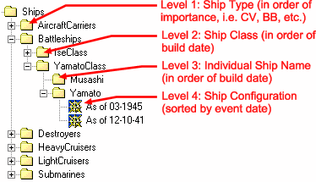
This browser will be the standard method of finding a ship in the navy. It is implemented in a rather complex manner. The top level of browsing is ordered by the type of ship, in order of their importance, namely:
- Aircraft Carriers
- Battleships
- Heavy Cruisers
- Light Cruisers
- Destroyers
- Submarines
- Patrol Craft (and other small combatants)
- Auxiliary Vessels
Within each type of vessel will be various classes of those vessels, arranged in order of build date of the lead member of the class, in descending order. For instance, the Imperial Navy had five classes of battleships operative during WWII. In order of build date, they were:
- Kongo Class (the oldest)
- Fuso Class
- Ise Class
- Nagato Class
- Yamato Class (the newest)
Within each class of vessel, there will be from one to many vessels, arranged in order of date the ship was laid down (i.e., lead ship of the class at the top of the list.) Thus, within the Yamato class, the list is arranged:
- Yamato (first laid down, i.e., the oldest)
- Musashi
- Shinano (last laid down)
Finally, each ship may have had several configurations (each of which was spawned by a refit event or some such). This is the central point of the database—to be able to easily track these different “looks” of the ship as the ship changes during the war. These configurations are arranged in descending order, by date:
- Configuration 12/10/1941
- Configuration 03/1943
- Configuration 04/07/1945
Double clicking on any of these configuration dates would cause the ship’s data window for that date to be placed in the main panel.
Note: Granted this method of browsing ships may be rather difficult to implement from a coding logic standpoint. If need by, I can supply an exact listing of where I want each ship to appear in the hierarchy, although “hard-coding” the browser seems in-elegant. I think it is likely that the browser hierarchy may need to be cached so that it is not rebuilt dynamically each time the user changes the tree view. Note, too, that the graphical example provided above in this document is not really sorted in the correct, due to the vagaries of Windows in using a strict alphabetical listing order. It serves as only a graphical example.

Alphabetical Listing Mode
This would display a straight alphabetical listing of ships with their associated ship configuration events.

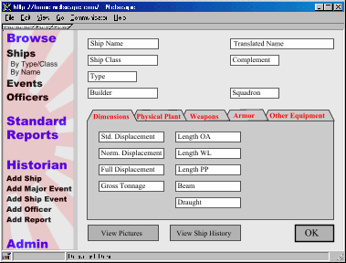
Ship Data Screen
The ship data screen contains a header area, a set of tab panels, and a footer area. The header area contains the following information:
- Ship Name
- Translated Ship Name—Japanese warships tended to have rather poetic names
- Ship Class—The class of warship, ex: “Yamato class,” “Shokaku class”
- Ship Type—Battleship, Aircraft Carrier, Heavy Cruiser, etc.
- Squadron—The basic organization to which the ship currently belongs.
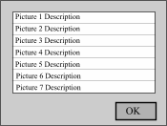
The footer contains the “View Pictures” and “View Ship History” buttons.
Pressing “View Pictures” will display a pick list with a description of any pictures associated with this ship. By double clicking on the description, the user can view the picture.
Pressing “View Ship History” will cause the Main Panel to fill with a TROM report for the ship in question. This will detail her building, movements, command changes, and any battles she participates in.
The mid-part of the ship data screen, as mentioned, contains a tab panel display. At present, I’ve arranged the tab panels into a set of five. Tab Panel One contains information on the displacements (standard, normal, full load, and gross tonnage for merchant vessels) and dimensions (length overall, waterline length, length between perpindiculars, breadth, and draught) of the vessel.
Tab Panel Two contains information on the machinery and performance of the vessel, including:
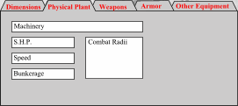
- Description of machinery
- Shaft horsepower
- Speed
- Fuel capacity in tons
- Cruising radii (miles at speed X)
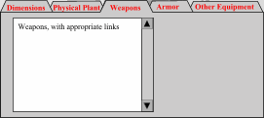
Tab Panel Three contains a listing of all the weapons carried aboard the ship, including:
- Guns
- Torpedo Mounts
- Torpedoes carried
- Rockets
- ASW mortars
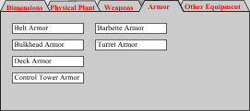
- Depth Charges
Tab Panel Four contains information on any armor carried by the vessel, including:
- Belt Armor
- Bulkhead Armor
- Control Tower Armor
- Deck Armor
- Barbette Armor
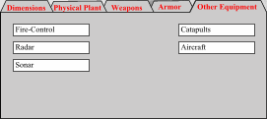
- Turret Armor
Tab Panel Five contains information on miscellaneous pieces of ship’s equipment, including:
- Fire-Control Systems
- Radar
- Sonar
- Catapults
- Aircraft

Ship Component Screens
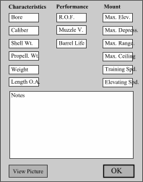
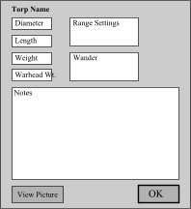
Ship component screens are spawned whenever a user clicks on an appropriate link inside the main ship’s data panel. This will usually occur as the result of someone browsing the ship’s equipment list, wanting more information on a specific component, and double-clicking on that component. Ship component screens are an exception to the rule that data screens (of whatever type) reside in the main panel of the application. Instead, ship’s components are “popped up” into their own smaller window which then “floats” over the application until closed by clicking on the upper left or right corners. There is a separate data screen for each of the major ship components:
- Guns
- Torpedoes
- Rockets
- ASW Mortars
- Sonar
- RadarIn general, these screens will be smallish in size, containing only enough real-estate for a picture and the data that accompanies the component.
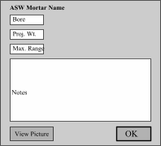
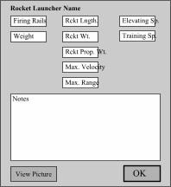
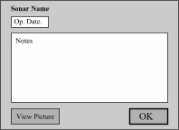
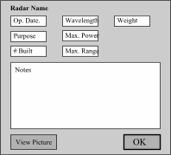

Event Browser
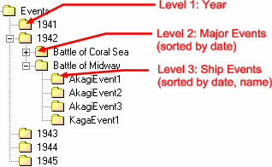
This is the standard method of browsing for a given historical event. Each year of the conflict is broken out separately, under which each of the major historical events is listed in date order. Each multi-ship event contains any associated ship events, listed by date and name of ship. It is important to remember that a multi-ship historical event such as battle may span several days, during which a given ship might have several ship-level events occurring which are all attached to the main historical event via one of the task forces linked to the main event.

Event Data Screens
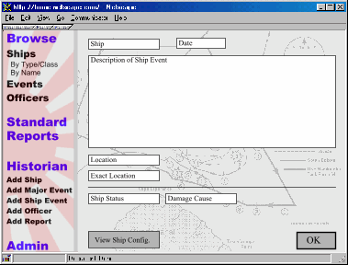
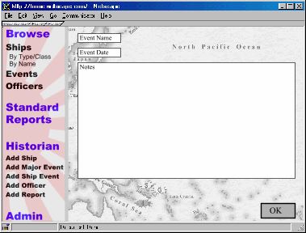
Both multi-ship and individual ship events have their respective data screens.

Officer Browser
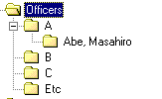
The officer browser will be perhaps the easiest to implement, as it will simply bring up an alphabetical listing of all the officers defined to the system. Double-clicking on an officer in the browser mode will bring up that officer’s profile in the data screen.

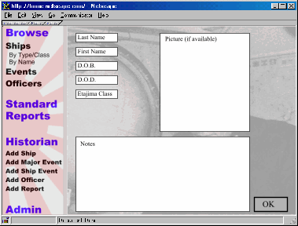
Officer Data Screen
The officer data screen displays pertinent information about naval officers. This includes
- Name
- Date of birth
- Date of death
- Date of graduation from Etajima Naval Academy
- Pertinent notes
- Picture (if available)

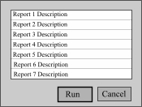
Standard Reports Screen

Run Standard Web Report
When the “Standard Reports” button is selected in the Navigation Panel, the Main Panel is populated with the standard reports screen. Standard Reports are often parameterized by date, since what happened within a given date range is often of interest to historians. The user would be presented with a menu of reports, including a description of each. After selecting a report, the user would be prompted for any necessary parameters. Examples of Standard Reports might be:
- List Ships Sunk By Type From Date X to Date Y
- List Ships Built By Type From Date X to Date Y
- List Ships Under Refit/Repair From Date X to Date Y
- List Ships of Type in commission (i.e. anything not sunk, regardless of status code) from Date X to Date Y
- List Tonnage of Ships Sunk By Type From Date X to Date Y
- List Tonnage of Ships Built By Type From Date X to Date Y
- Create OB for Date X (i.e., report all squadron affiliations for all ships not sunk)
- Create OB with Officers (same as previous, but with each commanding officer’s name appended to ship) for Date X
- List tonnage of ships of Type X built by Builders from Date X to Date Y
- List which vessels were in Port X between dates Y and Z
- List all transits (source and destination) between dates Y and Z
Some standard reports will be directly accessible from the various data windows, instead of through the Reports menu. At least one standard report will be offered directly from the Ship Data screen—“Generate TROM”. This report would detail all of the ship events for a given ship. Another standard report—“Generate Battle OB”—will be accessible directly from the Historical Event window. This report would create an OB (perhaps with ship captain’s names) for the historical event presently being viewed.

Historian and System Admin Features

Historian Functionality

Logon
Historians need a simple logon and password page to verify that they can access Historian Features.

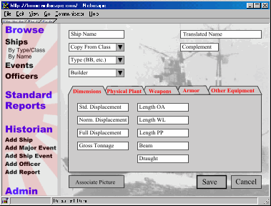
Add a Ship
Ships form the core of the system, as they form the core of any navy. The amount of data kept on any individual ship is fairly large—at least 30 attributes per ship, and a fairly long list of weapons would be the norm. As such, the data entry portion of the ship creation process needs to be efficient.

Instantiating Ships
Creating a new ship is the first step in being able to record that ship’s history. When a new ship is created, it sits in the database waiting for ship events to be attached to it (covered in more detail in the “Ship Events” section below). As a standard policy, the attributes entered when the ship is first created should be those that the ship will have when it is commissioned (i.e. when all of its equipment has been added and tested.) The overall process looks like this:
- Step One: Historian creates a new ship, and saves it to the database.
- Step Two: Historian creates a new ship event, corresponding to the laying down of the ship.
- Step Three: Historian creates a second ship event, corresponding to the launching of the ship.
- Step Four: Historian creates a third ship event, corresponding to the commissioning of the ship. At this point, the Historian also selects the “Change Ship Config.” button in the ship event screen.
- Step Five: The database searches for the last dated configuration of the ship. Finding none, it turns to the initial ship object created in Step One, and uses its attributes as the basis for the Historian’s forthcoming ship configuration definition.
- Step Six: Assuming the attributes previously entered in Step One match the characteristics of the vessel when it commissioned, the Historian can simply hit “Save” at this point. This configuration would then be matched to the date of the commissioning event, and would create the first actual ship configuration icon seen in the Ship Browser view for this vessel.
With that process in mind, let’s examine the steps needed to actually populate the initial ship data window.

Ship Name
Enter the name of the ship. [A non-blank value for this field is required.]

Copy from Class
Here’s an implementation issue. We need a way to quickly copy a new ship’s attributes from an existing ship. In my mind, there are two ways to do this. One would be to create init statements for every class of warship in the Japanese navy. These init statements would then populate the new warship with a default set of characteristics, weapons, and so on. That’s about fifty unique init statements that need to be written. The other approach would be to simply let the user copy a new ship from a list of all existing warships. So once a user has gone through the trouble of manually creating a representative of one class of ship, s/he has a template available from which to copy the rest of the members of the class. This approach is simpler to implement, but becomes more of a hassle as more and more ships are added to the database, and the user has to thumb through an increasingly long pick list of ships in order to select one to copy. I would personally prefer the first method, and accept that once the developer shows me how to do one representative init statement, I can grind out the other fifty.
In any case, in this drop-down menu the Historian would be able to select an applicable ship or class of ship on which to base the attributes of the new ship. The choice made in this drop-down would populate the Ship Class attribute. [A non-blank value for this field is required.]

Ship Type
From this pull-down, select the type of warship this is. Some of the more important choices are:
- Fleet Aircraft Carrier (CV)
- Light Fleet Carrier (CVL)
- Escort Carrier (CVE)
- Battleship (BB)
- Heavy Cruiser (CA)
- Light Cruiser (CL)
- Destroyer (DD)
- Submarine (SS)
Smaller combatant types (patrol boats, sub-chasers, etc.), and other specialized vessels (seaplane carriers, seaplane tenders, submarine tenders, etc.) will also be added. [A non-blank value for this field is required.]

Builder
From this pull-down menu, the Historian selects the building yard for the vessel. [A non-blank value for this field is required.]

Translated Ship Name
Enter the English rendering of the vessel’s name.

Ship’s Complement
Enter the ship’s complement.

Associate Picture Button
If a picture exists of the ship, clicking the “Add Picture” button would allow the user to browse to a file location and add the picture of the ship into the database [Note: at an implementation level, would the picture need to be copied into the database itself, or should we create a file location on the Web site and simply create an association with the file? Since Admin and Historian users would be accessing this application through the Web, uploading the file into the database remotely might constrain the performance of the application. By uploading picture files first to a file folder on the Web server, and then creating an association (perhaps simply entering the URL to the picture itself) we would avoid this problem.]
The first tab panel on the Ship Data screen contains the following items.

Standard Displacement
Enter the standard displacement of the vessel at this date

Normal Displacement
Enter the normal displacement of the vessel at this date.

Full Displacement
Enter the normal displacement of the vessel at this date.

Gross Tonnage
This field is provided in the thought that merchant ships and attack transports may eventually be populated in the database. This measure of displacement is inappropriate for warships.

Length Overall
Enter the overall length of the vessel at this date. For the time being, we’ll use feet and inches.

Length at Waterline
Enter the waterline length of the vessel.

Length Between Perpindiculars
Enter the length between perpindiculars of the vessel.

Beam
Enter the maximum beam of the vessel.

Draught
Enter the maximum draught of the vessel.

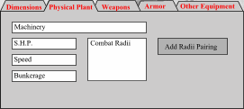
The second tab panel contains the following items pertaining to the physical plant of the ship.

Machinery
Enter a description of the ship’s power plant. Ex: “4-shaft Kampon geared turbines, 12 Kampon boilers.”

Shaft Horsepower
Enter the maximum shaft horsepower of the vessel.

Speed
Enter the maximum speed of the vessel using this powerplant.

Bunkerage
Enter the maximum tonnage of fuel carried by the vessel.

Add Combat Radii Pairing Button
The cruising radius of a ship is expressed in pairs: X miles at Y knots. A ship may have several known power settings, leading to several set of combat radii.

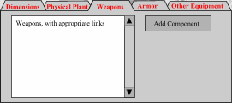
The third little tab panel contains information on the ship’s weapons.

Add Component Button
The Historian may select appropriate weapons from a pick list, and specify the quantity of the component as well. As described previously in this document, it is unclear to me whether this feature should be implemented so that the Historian selects weapons on the basis of mounts, or simply increments or decrements the total number of barrels, torpedoes, etc.
The fourth tab panel details information on the ship’s armor. Each of the armor fields holds a numeric value in inches.
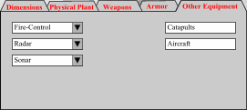
The fifth tab panel contains information on the ship’s miscellaneous equipment.

Fire-Control
The Historian selects from a pick-list of available fire-control systems. Multiple selections may be made (to reflect low-angel and high-angle AA systems being aboard the same vessel.)

Radar
The Historian selects from a pick-list of available radar systems. Multiple selections may be made (to reflect air search and surface search equipment being aboard the same vessel.

Sonar
The Historian selects from a pick-list of available sonar systems.

Catapults
Historian enters the number of catapults.

Aircraft
Historian enters the number of aircraft.

Save Ship Button
The ship is saved. The ship screen remains in place, ready to create another ship of the same class. If the user doesn’t want to create another ship, s/he hits “Cancel.”

Cancel Button
The ship is canceled, and the Main Panel returns to the previous browser mode.

Edit a Ship
Edit a ship’s attributes entails selecting the date/configuration of the ship in question from the ship browser and double clicking it. This would bring up the ship data screen for this date. The Historian would then be able to edit any attributes of the ship in question, and re-save them to the same dated ship configuration. Almost any attribute of the ship is eligible for editing. This includes some fairly un-intuitive options, such as:
- Ship Name—Ships did occasionally have their names changed, as in the case of older Japanese destroyers which were renamed as “Patrol Boat #NN.” However, the ship remains the same ship.
- Ship Type—Ships were converted from one type to another, while still retaining the same name. Ex: the seaplane carriers Chitose and Chiyoda, which were converted to light aircraft carriers during the early years of the war.
- Physical Dimensions—Ships were often drastically altered during their lifetimes, causing length, breadth, and displacements to vary.
- Armor—Armor was occasionally changed during the course of refits and re-constructions (a la the Kongo-class battleships).
Two attributes, however, can not be changed:
- Ship Class—Once a Chitose-class whatever, always a Chitose-class, even if the ship’s type changes as a result of a refit.
- Ship Builder—Wherever a ship was initially built was where it was initially built.

Delete a Ship
Selecting a ship folder (not an individual ship configuration inside the ship folder) in the Ship Browser, and then hitting the Delete key, will cause a confirmation window to appear asking if you really want to delete this ship. Hitting “no” would revert the user to the previous browser mode. Hitting “yes” would delete the ship and remove any associated ship events. Obviously, this action has the potential to undo a great deal of work, so it should only be used in extreme cases.

Add a Multi-Ship event
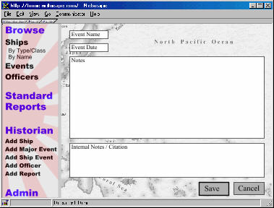
Multi-ship events form a framework into which individual ship events can be placed. Deciding what constitutes a ‘major’ event is somewhat subjective, but generally, any multi-ship operation of more than several days duration might reasonably be considered a ‘multi-ship event’ for the purposes of this database. Named battles, convoys, landing operations, even escorting a wounded warship to port, certainly all qualify. Multi-ship events don’t require all that much information to be attached directly to them, since the individual ship events, and the association between those vessels, provides the meat of the matter. There are only three attributes required to form a multi-ship event:

Name
The name of the event. Ex: “Battle of Midway.” The name need not be unique, however, it should be as descriptive as reasonably possible within the confines of a few words. [A non-blank value for this field is required.]

Date
The date the event began. [A non-blank value for this field is required.]

Description
Any description of the event required. For a battle, this might comprise an introductory paragraph or two to detail the general flow of the battle. Again, the individual ship events will also provide much of this detail. [A non-blank value for this field is required.]

Internal Notes / Citation
The Historian can enter internal notes and/or citation information on this entry.

Save Event Button
The multi-ship event is saved. The application displays a confirmation message that the event has been saved to the database. The event screen remains in place, ready to accept another event entry. If the user doesn’t want to create another event, s/he hits “Cancel.”

Cancel Button
The multi-ship event is canceled, and the Main Panel returns to the most recently used browser view.

Edit a Multi-Ship event
By double clicking on a multi-ship event in the Event Browser, the Multi-ship event screen will be brought up, wherein the event information can be edited, and then saved.

Delete a Multi-Ship event
Selecting a multi-ship event in the Event Browser, and then hitting the Delete key, will cause a confirmation window to appear asking if you really want to delete this event. Hitting “no” would revert the user to the previous browser mode. Hitting “yes” would delete the Multi-ship event and remove any associations this event had with ship events.

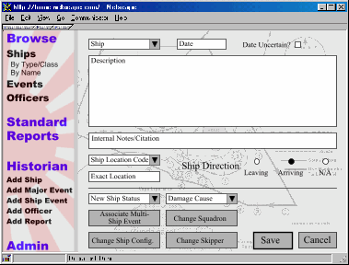
Add a Ship Event
Ship events are where the nitty-gritty operational details of individual vessels are entered. A preliminary design for the user interface is presented at right:

Ship
The name of the ship in question can be either typed in, or selected from a drop-down menu. To speed typing, the program will automatically populate this field with the name of the last ship for which a ship event was created. This field should perform validation to ensure that a valid ship is entered. [A non-blank value for this field is required.]

Date
The user must enter a date. This field should perform validation to ensure that a valid date is entered. [A non-blank value for this field is required.]

Date Tentative Flag
The user may check the “Date Tentative” flag, indicating that the ship event in question may or may not have occurred precisely on the date entered.

Event Description
The Historian can enter a description of the event, which often describes the role of the individual ship as it pertains to a larger Major Historical Event. This field must not be blank in order for the event to be saved. [A non-blank value for this field is required.]

Internal Notes / Citation
The Historian can enter internal notes and/or citation information on this entry.

New Ship Status
The user enters a new ship status code, (probably from a pull-down menu of some sort). Ship status codes are designed to convey the state of the ship at the end of the event being described. Entering a code is required in order to save the event. Allowable ship status codes are:
- Building—the ship has been laid on the ways, and the hull and major machinery are being built.
- Fitting Out—the ship has been launched, docked, and is receiving the balance of its equipment. Builder’s trials will also take place during this stage (which lasts until the ship is commissioned.)
- Active—the ship has been commissioned and is in active military service. Note: this should be the default value. Tabbing through this field, or typing an “a”, should populate the field. Otherwise, the user will need to use the pull-down to enter the code.
- Reserve—the ship is commissioned, but has been placed in a lower state of readiness for war, and likely has a reduced crew size. The vessel may have been designated as a training vessel. This is most often a peacetime state.
- Damaged—the ship has been damaged.
- Inoperable—the ship has been so damaged as to be rendered inoperable or immovable (i.e., hulked, beached, grounded), although it remains in commission.
- Refit/Repair—the ship is being repaired or is undergoing modification of its systems. The reason for lumping these two activities together is that during a war both actions often took place simultaneously and were impossible to segregate.
- Sunk—The ship is sunk.
- Removed—The ship, having been sunk, is formally removed from the Navy’s rolls.
If a ship is moved into either a Damaged, Inoperable, or Sunk state, the user must also enter a Ship Damage Cause, as below.
[A non-blank value for this field is required. Ship Status Codes should be table-driven, and maintained by the Admin user. It is anticipated that these codes will not change. A command line interface to maintain these codes would be appropriate.]

Ship Damage Cause
In those cases where a ship was Damaged, rendered Inoperable, or Sunk (and only in those three cases), the Ship Damage Cause drop-down menu will become active, and a Ship Damage Cause must be selected. These include:
- Surface Gunfire
- Surface Gunfire & Torpedo
- Torpedo—Submarine
- Torpedo—Aerial
- Torpedo—Surface Ship
- Torpedo—MTB
- Aerial Bomb
- Mine
- Friendly Fire
- Grounded
- Foundered
- Collision
- Ramming
- Misc. or Unknown
Note: In those cases where a ship is damaged by more than one damage cause in succession, it may be advisable to create separate events. Ex: a destroyer might be grounded, and subsequently sunk by aerial attack. These would be listed in two events. If such a segregation is not possible, a judgement as to the primary cause of the damage must be made.
[Damage Cause Codes should be table-driven, and maintained by the Admin user. It is anticipated that these codes will not change. A command line interface to maintain these codes would be appropriate.]

Quick Ship Location and Ship Direction
It is useful to be able to report on the direction and duration of ship movements, as well as being able to ascertain the duration of their stays in port. This is accomplished by two primary controls; the Quick Ship Location code, and the Ship Direction radio buttons. Quick Location codes will provide a pull-down menu pre-populated with an alphabetical listing of major points of operation, i.e. harbors, ports, and other anchorages, such as Yokosuka, Sasebo, Truk, etc. The Ship Direction radio buttons are intended to convey whether the ship in question is entering or leaving the location. The three possible states for the button are Leaving/Arriving/Not Applicable. Through the combination of these two pieces of data, one can pin down the location and purpose of a ship fairly precisely.
[Ship Location Codes should be table-driven, and maintained by either Admin or Historian users. An easy to use method for maintaining this table will need to be developed.]

Exact Location Field
The Exact Location field is intended to capture precise latitude and longitude entries for pinpointing locations of events (primarily ship sinkings). This field should enforce an appropriate validation rule for entering such data. [Note: If it is possible to use the same field to capture ship location codes and latitude/longitude entries, this would be preferable. Eventually, I would intend to make a linkage between a Location Code and it’s true latitude/longitude, so that a map interface for the program could be developed.]

Associate with Major Historical Event Button
By selecting this button, the Event Browser is brought up, with the addition that a Save/Cancel button is located on the browser screen. The user may browse and select a Major Historical Event. Hitting Save will cause this officer to be listed as the new commanding officer of the ship in question. Double clicking will have the same effect as hitting Save. Once the new commanding officer association is saved, the user is returned to the Ship Event in question.

Ship Squadron Change Button
By selecting this button, the user would be presented with a drop-down list of all squadrons in the database. The user may then select the new squadron affiliation for this vessel. Hitting the Save button would cause the new squadron affiliation to be tied to the Ship Event which spawned it. Once the squadron change is saved, the user is returned to the Ship Event in question.

Ship Configuration Change Button
By selecting this button, the user would cause the ship data window to appear. The user may then make changes to the ship’s equipment and other characteristics. Hitting the Save button would cause the new ship configuration to be tied to the Ship Event which spawned it. This will have the effect of placing a new ship configuration icon in the ship browser view at the date of the ship event. Once the configuration data is saved, the user is returned to the Ship Event in question.

Skipper Change Button
By selecting this button, the user will cause the officer browser window to appear, with the addition that a Save/Cancel button is located on the browser screen. The user may browse and select a new officer. Hitting Save will cause this ship event to be associated with the Major Historical Event in the browser. Double clicking will have the same effect as hitting Save. Once the event association is saved, the user is returned to the Ship Event in question.

Save Event Button
The ship event is saved, along with any associated ship configuration changes, or commanding officer changes. The application displays a confirmation message that the event has been saved to the database. The event screen remains in place, ready to accept another event entry. The Ship drop-down is pre-populated with the name of the same vessel. If the user doesn’t want to create another event, s/he hits “Cancel.”

Cancel Button
The ship event is canceled, and any associated ship configuration changes, or commanding officer changes are deleted.

Edit a Ship Event
By double clicking on a ship event in the Event Browser, the Ship Event Screen will be brought up, wherein the event information can be edited, and then saved.

Delete a Ship Event
Selecting a Ship Event in the Event Browser, and then hitting the Delete key, will cause a confirmation window to appear asking if you really want to delete this event. Hitting “no” would revert the user to the previous browser mode. Hitting “yes” would delete the Ship Event and remove any associations this event had with an officer. It would delete any ship configuration that had been previously associated with the event, and remove that individual ship configuration from the Ship Browser view.

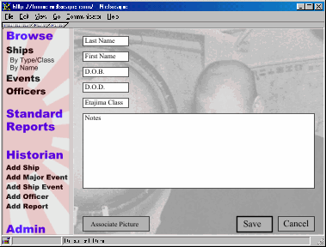
Add an Officer
This action is initiated by selecting the “Create Officer” option on the Navigation panel. Upon the Admin or Historian user selecting this option, the Main Panel would be replaced with the officer entry screen, where the following things can be done:

Last Name
Enter the last name (family name) of the officer. [A non-blank value for this field is required.]

First Name
Enter the first name or initial of the officer. [A non-blank value for this field is required.]

Etajima Class
Enter the graduation date of the officer from Etajima naval academy.

D.O.B.
Enter Date of Birth

D.O.D.
Enter Date of Death

Notes
Any needed notes on this individual.

Add Picture Button
If a picture exists of the officer, clicking the “Add Picture” button would allow the user to browse to a file location and add the picture of the officer into the database.

Save Officer To Database Button
Save this officer file to the database. Indicate that “Officer Added Successfully”. Clear the screen so that a new officer can be entered.

Cancel Button
Clear the screen and return the Main Panel to the previous browser view (ship, event, or officer)

Edit an Officer
This action is performed in the Browse Officer View. Double clicking on an officer in the browser view will bring up this Officer information screen (as above in “Create an Officer”), wherein the officer’s profile information can be edited, and then saved.

Delete an Officer
Selecting an officer in the Officer Browser, and then hitting the Delete key, will cause a confirmation window to appear asking if you really want to delete this officer. Hitting “no” would revert the user to the previous browser mode. Hitting “yes” would delete the officer and clear any associations this officer had with previously entered ship events. The events themselves would not disappear, but would no longer be associated with the deleted officer.

Add a Report
The Administrator and Historians need the ability to be able to define a new report and enter it into the Standard Reports drop down menu in the End-User application.
Standard reports would have the following attributes:
- Name: A brief name of the report, i.e. “Ship Sinkings” [A non-blank value for this field is required.]
- Description: A more descriptive narration of what the report will do. [A non-blank value for this field is required.]
- SQL: The actual query against the database. End users would not see this information. [A non-blank value for this field is required.]

System Administrator Functionality

Logon
The administrator needs a simple logon and password page to gain access to the Administrative and Historian features.

Create New System User
Input a new named Historian (ex. “Allyn Nevitt”). Prompted for a login and password for that Historian. Save/Cancel to either accept the changes or cancel out of the operation.

Edit System User
Select a Historian from a drop-down list. Change login and/or password for that Historian. Save/Cancel to either accept the changes or cancel out of the operation.

Delete System User
Select a Historian from a drop-down list. Delete that Historian, with Yes/No confirmation.

Miscellaneous Database Maintenance Utilities
The Admin user will need the ability to add, maintain, or delete the following items:
- Ship Components, including:
- Guns
- Torpedoes
- Rocket Launchers
- ASW Mortars
- Radar
- Sonar
- Fire-Control Systems
- Ship Classes
- Ship Types
- Building Yards
- Damage Cause Codes
- Quick Location Codes (?)
- Ship Status Codes
- Squadrons
Simple command-line utilities which pass a string to initialize the new object instance will be sufficient for these purposes, provided they are adequately documented.

Technical Requirements

Application Architecture
The application must be a multi-tiered design, with separation of interface, business logic, and database layers. I have no way of guaranteeing that this application will live forever on one site, so database and UI transportability are important.

User Interface
I anticipate that the interface will require a level of information density greater than standard HTML can provide. For instance, it seems clear that presenting the ship information compactly will require the usage of some sort of tab panel control, although this can be “faked” in HTML by using a screen design that imitates a tab design. I am open to using Swing, DHTML, or Javascript to develop these controls. I understand that there are differences in implementing DHTML or Javascript depending on whether Netscape or Internet Explorer are used. I am completely open to using whatever UI-builder tools the developer is most comfortable with, and then specifying to end-users that they need to use “Browser X” in order to interact with the system. Upgrading or switching browsers should not be a barrier to most users.

Database
I had originally intended to deploy this application using ObjectDesign’s PSE Pro object database as a back-end. This had the advantage of minimizing the problems with coding an object-relational persistence layer for the application. PSE Pro retails for about $99.
I am also open to other object (maybe Poet?) or relational database options. SQLServer is a possibility, as I think I can wangle a copy for deployment from friends who have Web sites already running it as a back-end. I am also open to shareware relational databases. Whatever the choice, the cost of purchase must be minimal.

XML
It has been suggested to me that coding the ship data objects as XML documents might be a very handy way to keep the information transportable, and more usable by future applications. I have some examples of DTD files for the ship classes provided by a co-worker, should the developer wish to view them.

System Loading
My site receives an average of about 250 visits a day. This application will replace most of the static HTML on the site, in terms of finding ship information. Therefore, it should be anticipated that several people, and perhaps upwards of a couple dozen, would be hitting the database simultaneously.

Additional Considerations

Intellectual Property Stuff
My intent is to make this an Open Source Software (OSS) application. I am currently researching appropriate licensing verbiage.

System Documentation
Good source code documentation is essential to the success of this project. It is anticipated that several developers may touch the application during the course of its lifetime. Furthermore, the author has entertained notions of making the application an Open Source Software (OSS) application whose source will be available on the Web site for anyone to enhance. As such, clear documentation is crucial.
The author can offer assistance in this regard. I have technical writing skills, and can augment the developer’s abilities in this area, if needed. However, this goal will be aided greatly by the developer’s choosing variable and other instance names that are intuitive and clear.

My Skill Set
As the above paragraph indicates, I will do everything in my power to offload duties from the developer which lie outside development. As a business analyst for a Web development firm, my skill set is reasonably technical, but falls short of a true developer’s. My skills are as follows:
- A very strong understanding of the problem domain (the Pacific War, and naval warfare in general).
- Experience in object-oriented fundamentals, and basic design principles.
- Experience with Rational Rose for object modeling.
- Basic data modeling skills.
- Strong basic HTML skills (but no experience with DHTML or Javascript)
- Basic skills with Dreamweaver.
- Strong production graphics skills, including using tools such as Adobe Photoshop, Corel Xara, Paintshop Pro, etc. I am not a graphic designer, but I can certainly crank out production graphics.
- Strong writing skills, technical and otherwise.

Appendix One: Use Case
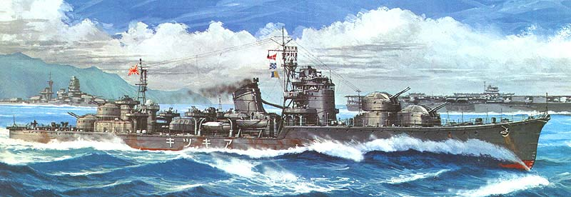
The following is an example of a real-life tabular record movement (TROM) of an actual Japanese destroyer, the Akizuki. This TROM will serve as the basis of a use case illustrating how the operations database would be used to create a record for a warship and track it through the war.
July, 1940: Laid down at Maizuru Naval Dockyard.
The first thing to be done is to create a new ship of the Akizuki class named “Akizuki.” This particular ship would be created with Maizuru Naval Dockyard as the builder. Next, we’ll create our first ship event, which we’ll initialize on July 15th (the midpoint of the month) and mark as a tentative date (since we apparently don’t know the exact date of her keel laying) by checking the “?” box next to the date. We mark her location code as “Maizuru,” with a direction code of “N/A,” and mark her status as “Building.”
July 2, 1941: Launched at Maizuru.
We create a second ship event, and change Akizuki’s status code to “fitting out.” Her location remains “Maizuru”, and her direction remains “N/A”
11 June 1942: Completed at Maizuru. Ship's captain: Commander Koga Yasuji.
Create a new officer, for Koga Yasuji. Then create a new ship event. Ship status is now changed to “active.” The ship event is associated with Koga Yasuji. The ship event is also associated for the first time with the Akizuki ship instance, which is already populated with the proper attributes to represent her at her time of commissioning. Up until this point, Akizuki had no attributes, as she was just a hull being fitted out.
15 June: Departed Kure, escorting ZUIKAKU to Northern Area in expectation of U.S. counterattack in the Aleutians.
Create a new multi-ship event, entitled “Escort Zuikaku.” Create new ship event. Set ship location code = “Kure,” ship direction = “leaving.” Associate ship event with the multi-ship event.
Note, too, that we have no idea when Akizuki returned to port from her escort mission, or where she returned. One might presume that she went out with Zuikaku, and they returned in consort to Yokosuka, but it is not known. We might want to do some digging into Zuikaku’s records, as well as those of any other ships associated with this operation.
29 June-18 July: Escorted liner KAMAKURA MARU from Yokosuka to Makassar (6-10 July) and back.
Create a ship event dated June 29. Indicate location code = “Yokusuka,” ship direction = “leaving.”
Create a subsequent event dated July 18. Location code = “Yokusuka,” ship direction = “arriving.”
Note that we don’t know when Akizuki and her charge actually arrived in Makassar to deliver their cargo, so we’ve lost two ship events in the middle of the round trip. Operational studies aren’t an exact science, and may of the Japanese records have been lost… so it goes.
13-21 August: Escorted ammunition ship NARUTO MARU from Yokosuka via Kavieng to Rabaul.
Create a ship event dated August 13. Ship location code = “Yokosuka,” direction = “leaving.”
Create a ship event dated August 21. Ship location code = “Rabaul,” ship direction = “arriving.”
We might also do some research on normal transit times from Kavieng to Rabaul (my guess is that it would be an overnight trip.) If we felt confident enough in our assessment, we might create a set of events in the middle of the Yokosuka→Rabaul transit which would capture Akizuki’s stop at Kavieng. If so, we would definitely mark those dates with the tentative flag in the ship event, indicating that we know approximately when she was in Kavieng, but not exactly.
24 August: Battle of the Eastern Solomons. Joined escort of Admiral Nagumo's Striking Force.
If it’s not there already, create a multi-ship event entitled “Battle of the Eastern Solomons.” Create a ship event dated August 24. Associate Akizuki with the multi-ship event, probably to the “Striking Force” task force. We don’t have much detail on her role in the battle, but her association with the event helps us build an OB for the battle.
With a little more research, we would also likely be able to create an additional ship event for Akizuki pinpointing the exact date when she returned to Truk with the rest of the Striking Force. We would also associate this ship event with the multi-ship “Battle of the Eastern Solomons.”
September: Escorted fleet patrolling out of Truk north of the Solomons.
Create a new multi-ship event, entitled “Fleet Patrol” or something (hokey sounding, but we can always re-name it later. Set the date as September 15th (mid-point of the month), and mark it tentative. You’ll probably want to make a note of the extreme vagueness of the date in the notes field associated with the multi-ship event.
Create a new ship event dated (tentatively) on September 15th , and associate Akizuki with it.
27-30 September: Steamed from Truk to Shortlands. On 29 September weathered attack by B-17s without damage.
Create a standard 2-event transit from Truk to Shortlands.
3 October: Out of Shortlands to assist NISSHIN against U.S. aircraft.
Create new ship event. Location code = “Shortlands,” direction code = “leaving.”
7 October: Escorted NISSHIN on troop transport run to Guadalcanal, aborted due to weather; on same date, assigned to Desdiv 61, Desron 10, Third Fleet.
This event is tricky. It is unclear if Nisshin was en-route to Guadalcanal from a location other than Shortlands, and Akizuki joined her in mid-transit, or what the deal is. Regardless, we’ll need to create a multi-ship event for Akizuki to join at some point. Also in this ship event, we will associate Akizuki with DesDiv 61.
8 October: Escorted NISSHIN on troop transport run to Guadalcanal.
Again, a very vague description of where these ships were emanating from. Nevertheless, we’ll create a multi-ship event for this operation, and a ship event, and associate Akizuki with them.
11 October: Escorted NISSHIN and CHITOSE on troop transport run to Guadalcanal.
Still more vagueness, but same general procedure as above.
12-16 October: Became flagship of Comdesron 4 (Rear Admiral Takama Tamotsu), then led escort of troop convoy from Shortlands to Guadalcanal and back.
We’ll make a ship event, note the new flagship status in the notes field, but this does not affect Akizuki’s affiliation with DesDiv 61 in any way. In all other respects, this is a standard 2-event transit.
17 October: Led troop transport run to Guadalcanal (cover).
We don’t know from where Akizuki transited from. We may be able to derive this from other sources, as Shortlands seems the most likely culprit. Probably a 2-event transit.
25 October: Led gunfire support mission to Guadalcanal (Hyakutake offensive), aborted. Assisted in rescue of survivors from bombed YURA. Medium damage: when near-missed by U.S. aircraft and left temporarily unnavigable due to damage in engineering spaces. Admiral Takama transferred to MURASAME.
Ah ha! Damage. Create a multi-ship event called “Bombardment Mission” or some such. Create a ship event. Associate Akizuki with the event, and change her status =
“damaged,” and damage cause code = “aerial bomb.” Since she was only temporarily dead in the water, we’ll not list her as being “inoperable.”
27-31 October: Alongside repair ship HAKKAI MARU at Rabaul.
Create an October 27 ship event. Ship status remains damaged. Ship location = “Rabaul.” Ship direction = Arriving.” Judging from the next entry, Akizuki must have left Rabaul October 31 (or slightly before) and skedaddled up to Truk. Given the known distance between these two points, we can probably construct some tentative transit dates to get her from Rabaul to Truk. Her ship status this whole time has remained as “damaged.”
1-6 November: Escorted SHOKAKU and CHIKUMA from Truk to Japan, then docked at Yokosuka for repairs.
Create a multi-ship event. You know what to do—2-event transit. Ship status is still “damaged.”
16 December: Repairs completed.
New ship event with ship status now = “active.”
31 December 1942-4 January 1943: Escorted ZUIKAKU from Yokosuka to Truk.
Standard multi-ship transit.
6-11 January: Became flagship of Comdesron 10 (Rear Admiral Kimura Susumu), then steamed from Truk via Rabaul to the Shortlands.
Again, given the relative “tightness” of the schedule, we could probably make some educated tentative dates for her stop at Shortlands. In the first event, we will note the command change, although Akizuki’s immediate affiliation remains with DesDiv 61.
14 January: Led troop transport run to Guadalcanal (cover).
Same type of event as our pervious cover missions. Given the date, one assumes these emanated from Shortlands, and probably involved more than one vessel.
19 January: Out of Shortlands to assist torpedoed transport MYOHO MARU. Medium damage: when torpedoed by USS NAUTILAUS (SS-168). Two torpedoes hit but one was a dud. Starboard engine room flooded, keel severely strained, but able to steam at 20 knots; 14 dead and 63 injured, the latter including Admiral Kimura.
January 19 event will have ship status = “damaged,” via a “submarine torpedo.”
2 February-11 March: Arrived Truk from the Shortlands, then alongside repair ship AKASHI.
2-event transit from Shortlands to Truk. Judging from the next two entries, her status is still “damaged,” with repairs in Truk only correcting the worst of her problems.
11-14 March: Escorted transport TOKYO MARU from Truk to Saipan.
Standard 2-event transit.
14 March: Heavy damage: while leaving Saipan, damaged keel buckled under the bridge, nearly sinking ship. Towed back to Saipan on 15 March by auxiliary gunboat SHOEI MARU and beached.
Ouch, babe! We’ll create a second event dated March 14th, to indicate that she came in on the 14th from Truk, and left again the same day. But at the end of this event, her status = “inoperable,” with a damage cause = “Miscellaneous.” This last point is open to discussion, as the original damage cause was that torpedo hit, but you don’t want to double-count the hit for reporting purposes.
Create a March 15th event to indicate her arrival back at Saipan.
March-June: Emergency repairs by salvage ship MATSUNOURI MARU: bridge and forward turrets removed to lighten ship.
Yipes. Add to the previous March 15th entry that she is under repair by Matsunouri Maru.
24 June-2 July: Towed by transport SHINKO MARU from Saipan to Nagasaki, then docked for repairs. On 30 June designated a "Reserve Ship" while under repair in Japan.
Standard 2-event transit, but also create a third event in the middle, dated June 30th, wherein her status is changed from “inoperable” to “reserve.”
It is not stated, but if we know about any equipment changes to Akizuki, this would be a good time to research as to whether or not she received additional AAA armament and/or radar.
26 July: Commander Koga relieved of command.
Hmmm… don’t know how to model this one, as the new commander hasn’t arrived yet. In my object model, on can only “associate” a new skipper; one can’t manually “de-associate” the old one. Perhaps we’ll create a dummy skipper whose name will be “No Skipper”, who can preside in the interim.
8 October: Commander Ogata Tomoe appointed ship's captain.
Create a new officer (unless Ogata-san is a known quantity.) Create a new ship event, and associate the new skipper.
31 October: Repairs completed; reassigned to Desdiv 61.
Now this is interesting… I thought we were already attached to DesDiv 61! This suggests that when Akizuki was placed in reserve, her association with the squadron went away, too. We can address this directly in the logic of the system, or we can create a dummy squadron called “No Assignment” to handle these cases. We should probably then go back and change her squadron affiliation in the June 30 event.
Afterwards, create a new ship event and re-associate her with DesDiv 61.
26 November-1 December: Escorted SHOKAKU and CHITOSE from Iwakuni to Truk.
We have no information on how or when Akizuki transited from Nagasaki north to Iwakuni. And with nearly a month since her repairs were completed, we won’t venture a tentative dating. So just create a standard multi-ship transit for this new operation.
9-14 December: Supply transport run from Truk to Kwajalein (11 December) and back.
Nice 4-event transit, with a hard date in the middle.
30 December 1943-4 January 1944: Escorted NOSHIRO and OYODO on troop transport run from Truk to Kavieng (1 January) and back; on 1 January weathered attack by U.S aircraft without damage; on 3 January assisted torpedoed transport KIYOZUMI MARU.
Multi-ship mission. For Akizuki, there are actually six ship events associated with the multi-ship event, with the January 1st and 3rd events sandwiched between when the group left Kavieng to come back to Truk, and when they actually arrived Truk.
1-3 February: Escorted fleet from Truk to Palau.
Another multi-ship mission, 2-part event model.
16-21 February: Escorted fleet from Palau to Lingga.
Ditto.
12-15 May: Escorted fleet from Lingga to Tawitawi.
Ditto.
19-20 June: Battle of the Philippine Sea Escorted Admiral Ozawa's Force A. Assisted the torpedoed TAIHO and helped rescue survivors.
Multi-ship event, with Akizuki attaching her ship event to the “Force A” task force.
July-October: Upkeep and training in Japan.
Create a July 1st event, dated tentative, and note the duration in the notes field.
25 October: Battle of Leyte Gulf. Escorted Admiral Ozawa's Northern Force in Battle off Cape Engano. Sunk: by torpedo, ship blowing up five minutes after being hit, ENE of Cape Engano (20-29 N, 126-30 E). Most sources credit the hit to U.S. aircraft of TF 38, but some give credit to submarine USS HALIBUT (SS-232). Number of survivors unknown, but Commander Ogata was among them.
The end has come for poor Akizuki. Multi-ship event, with Akizuki attached to “Northern Force.” Ship status now “sunk.” We’ve got some conflict over the damage source, but we’ll stick with the standard sources and list the damage cause as “aerial torpedo.”
10 December 1944: Removed from Navy List.
Create a final ship event, dated December 10, and change ship status to “removed.”

Use Case Discussion
Seems pretty laborious, huh? In this event model, at a rough count, the user would create about 75 ship and officer events (not counting the multi-ship events to hold them, if they weren’t already created.) Well, two points to be made here. First, Akizuki had a fairly active career, and we know a fair amount about her movements, which means we can create a fairly accurate history. Second, I think that once the researcher gets into the groove, this process will become fairly intuitive and easy-to-use. The initial pain will be creating all the bloody multi-ship events to hold the individual ship events. When you factor in the convoys and all that, there are literally hundreds and hundreds of these to create. However, once the first hundred or so multi-ships are created, you’ll undoubtedly have the skeleton for all the major battles, and the majority of the “heavies” will fit into this framework. The convoys will be much more laborious, but they should also be relatively straightforward.

The bulk of this TROM was originally compiled by Allyn Nevitt, and is posted on my Web site. Except for the first three entries, which I compiled for this document, it is reproduced verbatim herein.

